Cook Book

Your Virtual Kitchen Assistant

**1. INTRODUCTION:**

* **Cook Book:**
* **Team ID: NM2025TMID39463**
* **Team Leader: Roshan Sithic S &** [**rsithics@gmail.com**](mailto:rsithics@gmail.com)
* **Team Members:**
* Ranjith G & [ranjithyamuna7358@gmail.com](mailto:ranjithyamuna7358@gmail.com)
* Sanjay G & [ssanjay06834@gmail.com](mailto:ssanjay06834@gmail.com)
* Thirumurugan S S T & [thirumurugan10th@gmail.com](mailto:thirumurugan10th@gmail.com)

**2. PROJECT OVERVIEW:**

* **Purpose:** To organize and share recipes through this project. You can learn the recipe of specific food.
* **Features:**
* Recipe title and description
* Ingredients list
* Step-by-step cooking instructions
* Preparation and cooking times

**3. ARCHITECTUE:**

* **Frontend:** React.js with Bootstrap and Material UI
* **Backend:** Node.js and Express.js managing server logic and API endpoints
* **Database:** MongoDB stores user data, project, information, applications, and chat messages

**4. Setup Instructions**

**• Prerequisites:**

**– Node.js**

**– MongoDB– Git**

**– React.js**

**– Express.js – Mongoose – Visual Studio Code**

**• Installation Steps:**

**# Clone the repository git clone**

**# Install client dependencies cd**

**client npm install**

**# Install server dependencies cd**

**../server npm install**

**5. Folder Structure**

**SB-Works/**

**|-- client/ # React frontend**

**|__components/**

**|__ pages/**

**|__ server/ # Node.js backend**

**|__routes/**

**|__ models/**

**|__ controllers/**

**6. Running the Application**

**• Frontend:**

**Cd client**

**npm start •**

**Backend:**

**cd server npm**

**start**

**• Access: Visit http://localhost:3000**

**7. API Documentation**

**• User:**

**– /api/user/register**

**– /api/user/login**

**• Projects:**

**– /api/projects/create**

**– /api/projects/:id • Applications: /api/apply**

**• Chats:**

**– /api/chat/send**

**– /api/chat/:userId**

**8. Authentication:**

**• JWT-based authentication for secure login**

**• Middleware protects private routes**

**9. User Interface**

**• Landing Page**

**• Freelancer Dashboard**

**• Admin Panel**

**• Project Details Page**

**10. Testing**

**• Manual testing during milestones**

**• Tools: Postman, Chrome Dev Tools**

**11. Screenshots:**

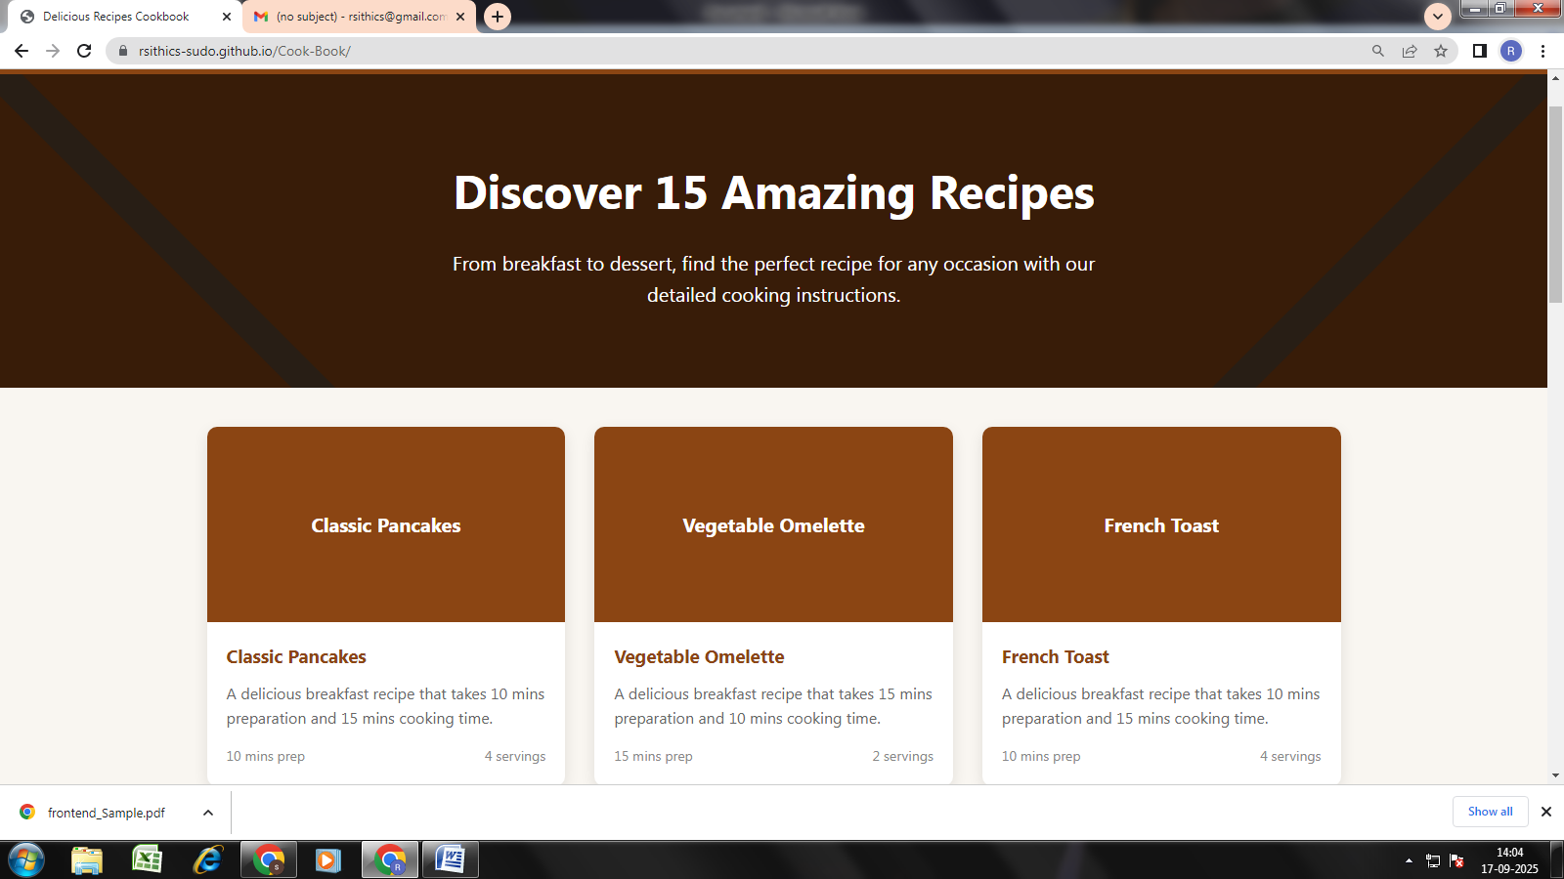

**12. Known Issues:**

**- Some kind of errors happen while clicking on recipes instructions**

**13. Future Enhancements:**

**- Advanced Personalization and AI Integration**

**- Interactive and Immersive User Experience**

**- Community and Social Features**

**- Monetization and Advanced Content**